Group 6: PROgrammers
HomeNeedsService.com System Software Design
Group Captain: Yessica Rodriguez 0414909
Oscar Torres 463454
Daniela Tamayo 20336461
Ulvi Bajarani 20539914

Table of Contents
1. INTRODUCTION 4
1.1. Purpose 4
1.2. Scope 4
1.3. Definitions and Acronyms 4
2. REFERENCES 4
3. DECOMPOSITION DESCRIPTION 4
3.1. DataStore Module Description 4
3.2. DataProcessing Module Description 6
3.3. UserInterface Module Description 6
4. DEPENDENCY DESCRIPTION 6
4.1. Inter-module Dependencies 6
4.1.1. Database 6
4.1.2. DataProcessing Module 7
4.1.3. UserInterface Module 7
4.2. Inter-process Dependencies 7
5. INTERFACE DESCRIPTION 7
5.1. Module Interface 7
5.1.1. DataStore Module Interface Description 7
5.1.2. DataProcessing Module Interface Description 7
5.1.3. Userinterface Module Interface Description 8
6. DETAILED DESIGN 8
6.1. Module Detailed Design 8
6.1.1. Database Detailed Design 8
6.1.2. Application Program Detailed Design 8
6.1.3. UserInterface Module Detailed Design 12
6.2. Data Detailed Design 17
6.2.1. Variable Definition Description 17
6.2.2. Variable Type Description 18
6.3. Process Integration 18
6.3.1. Routes 20

INTRODUCTION

Purpose
In this document, we describe the HomeNeedsService.com system software design. In Section 3, 4 and 5, we present the architecture of the system. In Section 6, we give the final details that guide the implementation of the system.

Scope
This design is for both the prototype and the operation versions of HomeNeedsService.com system software.

Definitions and Acronyms
HDBD HomeNeedsService.com Database Design
HNS HomeNeedsService.com
AWS Amazon Web Services

REFERENCES
Group 6: PROgrammers - HomeNeedsService.com System Database Design

DECOMPOSITION DESCRIPTION
At the high level, the HNS system consists of three modules, DataStore, DataProcessing, and UserInterface. Figure 3.1 gives structure chart of the system framework.
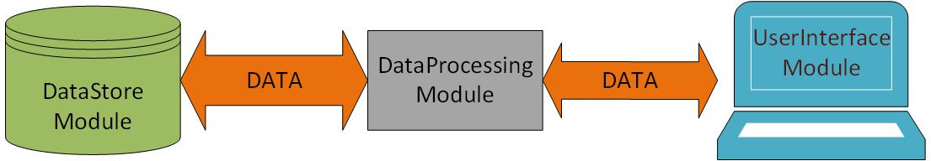
Figure 3.1. Structure Chart of DB_PROJECT Software Framework

DataStore Module Description
DataStore Module stores data that can be accessed and modified by DataProcessing Module to satisfy user requirements of data storing, updating, and querying. It is the database of the system, which consists of a collection of tables that may be relational to each other as described in HDBD. Figure 3.2 presents the structure of DataStore Module.
Refer to HDBD for detailed database able description.
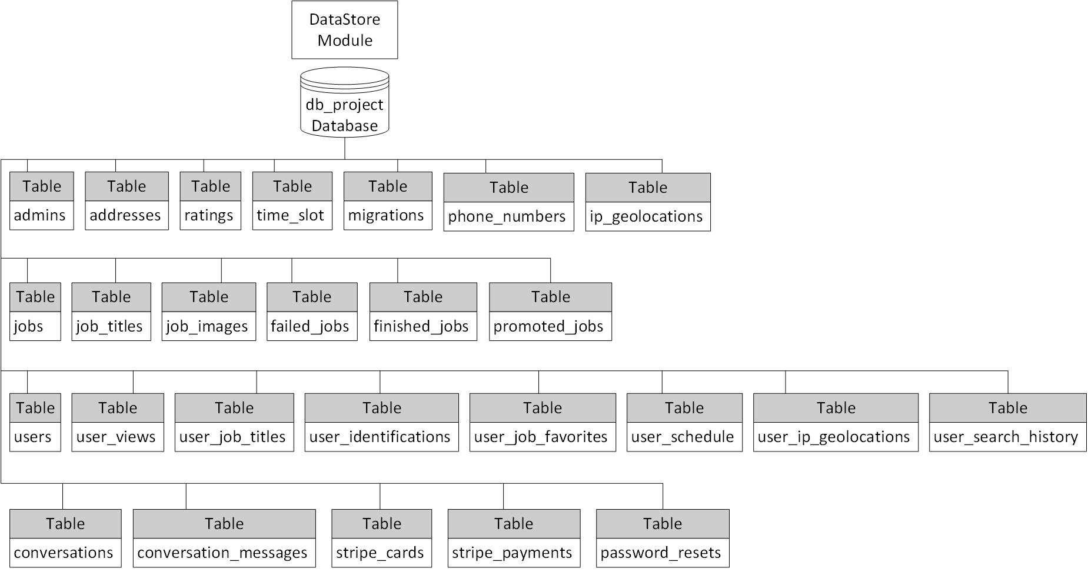
Figure 3.1. The Structure of DataStore Module

DataProcessing Module Description
DataProcessing Module performs all the operations that the HNS system provides to the users. It controls the data processing procedure of the system and generates the dynamic data of the web pages to the users. This module consists of 5 function sets, which are Computation Function Set, Database Connection Function Set, Data Retrieval Function Set, Data Update Function Set, and User Authentication Function Set.
Computational Function Set includes all the sub-functions that perform validation, formula calculation, and other computation required by users or application programs. Database Connection Function Set consists of the functions that connect to the database server. Data Retrieval Function Set consists of all the functions that retrieve specific data or information from the database. Data Update Function Set consists of all the functions that add new data to the database or modify original data of the database. User Authentication Function Set consists of all the functions of user authorization and session management.
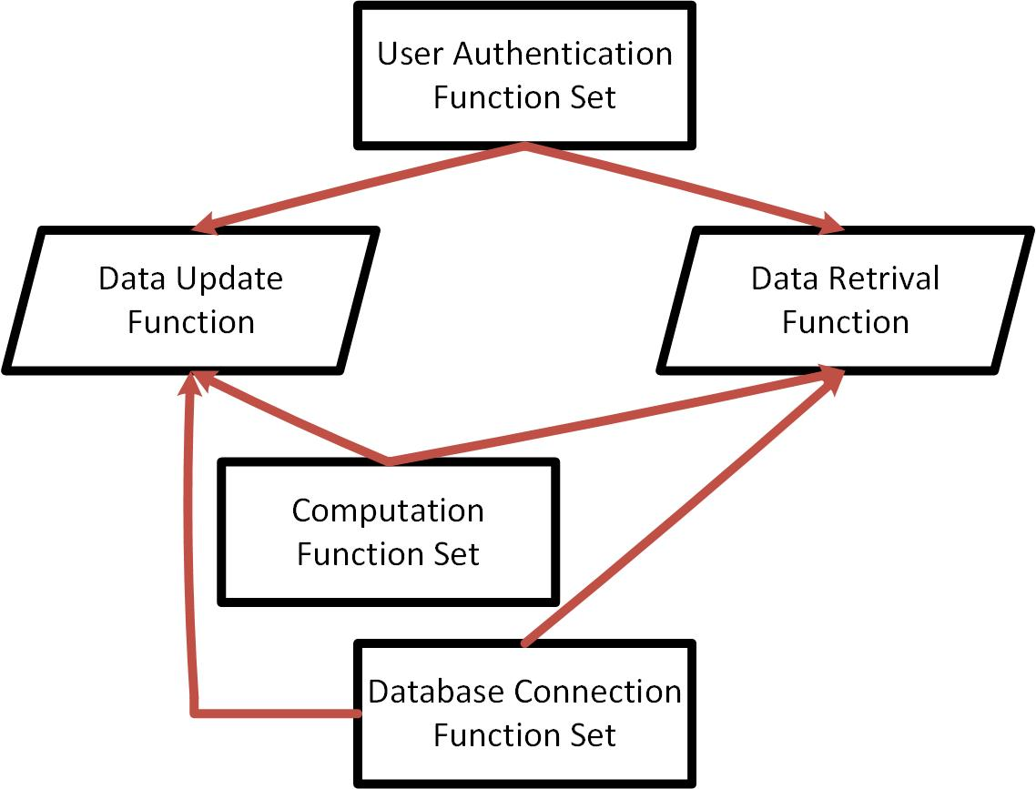
Figure 3.2 Function Call Relationship Diagram Among Function Sets
Figure 3.3 gives the function call relationship among function sets of the module. An arrow shows relationship from a callee to a caller. A caller can call a function in the function set that has an arrow line pointing to the caller.

UserInterface Module Description
UserInterface Module is used to maintain consistent appearances for all aspects of the system. It provides interfaces for users to interact with the system.

DEPENDENCY DESCRIPTION

Inter-module Dependencies

Database
The database resides in a server machine with the database named db_project.
The database can be accessed only by DataProcessing Module with authorized users through PDO_MYSQL. There are two data resources of this module, Use Input Data and System Generated Data. User Input Data are generated by authorized users, and System Generated Data are created authomatically by software functions.
Table 4.1 lists the resources on which DataStore Module depends. The attributes of the hardware are selected in order to satisfy demands of performance.
Hardware | Software
 | Amazon Web Services (AWS)
Table 4.1 SQL/Web Server Resources
Refer to ADBD v1.1 for dependencies between table

DataProcessing Module
DataProcessing Module resides and is executed in the same Web Server machine. This module accesses DataStore Module through PDO_MYSQL and exachanges data with UserInterface Module through AWS services. DataProcessing Module functions process and retrieval data from/to both DataStore Module and UserInterface Module.

UserInterface Module
The UserInterface Module resides on the same Web Server machine as DataProcessing Module and Database sharing the same resources. It generates HTML web pages for the users to interact with the system. The web pages can execute on any client PC that connects to the Web Server through Internet and can be accessed by any client PC to Web Server via a web browser such as Internet Explorer and Google Chrome.

Inter-process Dependencies
The functions of DataProcessing Module and static web pages of UserInterface Module are integrated into PHP files that are requested by the users from client machines and execute as process entities in the form o PHP code. For the relationship among these PHP entities, see Figure 6.3 for state transition diagram of all the PHP files.

INTERFACE DESCRIPTION

Module Interface

DataStore Module Interface Description
PDO_MYSQL Driver for mySQL is used to provide access to the DataStore Module. SQL language is used to carry out the operations of database accesses.

DataProcessing Module Interface Description
DataProcessing Module accesses database through PDO. SQL language is used to carry out the operations of database accesses. The DataProcessing Module inputs PHP code and http requests.

Userinterface Module Interface Description
Web Browser is used as in interface by UserInterface Module to interact with users. All information required by the users is presented to them via web browser. Users’ requests and their input data are sent to DataProcessing Module via HTTP requests.

DETAILED DESIGN

Module Detailed Design

Database Detailed Design
Refer to HDBD for the detailed description of the HNS database design.

Application Program Detailed Design
All the codes and images of the HNS software reside in db_project directory. All the sub-function codes reside in \db_project\app directory. All the application programs of the system are stores in \db_project folder. Table 6.1 lists the reservation directory of system software.
# | Content | Directory
1 | Sub-function Code | \db_project\app
2 | Image | \db_project\public\uploads
3 | Application | \db_project

Table6.1 Software Reservations

User Authentication Function Set

Authorization
Description: Determine if the login name is valid
Input:
User email address, password
Output:
Returns ‘true’ if the user is authorized.
Returns ‘false if the user is not authorized.
Pseudocode:
Begin
Retrieve record of user password from User table;
If there is no record of the user, then
Return false;
Else if password is not correct
Return false;
Else
Return true;
End

ForgotPassword
Description: Remind the user of his (or her) login password through
Email
Input:
User email address
Output:
None
Pseudocode:
Begin
Retrieve record of user email address and password from User table;
If there is a record of the user, then
Email user password to his (or her) email address;
End

Data Update Function Set

Register
Description: Insert new user profile in User table and all the user associated tables identified by their names starting with “user_”
Input:
User name, User email address, user password, user password confirmation
Output:
None
Pseudocode:
Begin
If user password and user password confirmation match, then
Insert the records of the user in User Table and user associated tables;
End

ResetPassword
Description: Modify or insert the profile of an identified nurse in User table
Input:
Token, Password, password confirmation
Output:
None
Pseudocode:
Begin
If token was correct, then
If password and password confirmation match, then
Update the records of identified user in User Table;
End

EditUser
Description: Modify the user profile of an identified user in User table and other associated user tables that are identified by starting with “user_”
Input:
- Entry 1: User name, user email address, or date of birth
- Entry 2: user id, job title id
- Entry 3: user id, driver license number or face picture
- Entry 4: user id, job id
- Entry 5: user id, ip geolocation id
- Entry 6: user id, time slot id
Output:
NoneEntry 5: user id, time slot id
Pseudocode:
Begin
If Entry 1, then
Update the records of identified user in User Table;
If Entry 2, then
Update the records of identified user in User_job_titles Table;
If Entry 3, then
Update the records of identified user in User_identifications Table;
If Entry 4, then
Update the records of identified user in User_job_favorites Table;
If Entry 5, then
Update the records of identified user in User_ip_geolocations Table;
If Entry 6, then
Update the records of identified user in User_schedule Table;
End

PostJob
Description: Insert a new job posting in job table
Input:
User id, address id, job title id, job description, time slot id, rate per hour
Output:
None
Pseudocode:
Begin
If there are records of user,
If there are records of job title,
If there are records of time slot,
If there are records of address,
Insert the records of the job in Jobs Table;
End

Data Retrieval Function Set

UserRetrieval
Description: Retrieve the identified user profile
Input:
User id (user email address and password)
Output:
Name, Email address, Date of Birth,
Job title id(s), driver license number, face picture,
Job id(s), ip_geolocations, time slot id
Pseudocode:
Begin
Retrieve the record of identified user from User table and all related user tables identified by starting with “user_”;
Return user information;
End

JobRetrieval
Description: Retrieve the identified job posting
Input:
Job id
Output:
User id, Name (posted by),
Address id, house number, predirectional, street, suffix, postdirectional, unit, apartment number, city, state, zip code, latitude, longitude,
Job title id, job title, job image url
Job description,
Job posted date and time,
Time slot id, day, start time, end time
Rate per hour,
Unique url,
Is finished by value
Pseudocode:
Begin
Retrieve the record of identified job from Jobs table and all related job tables identified by starting with “job_” or ending with “_jobs”;
Return job information;
End

Computation Function Set

UserRating
Description: Determine the user rating value based on user jobs completed ratings
Input:
User id, job id, satisfaction (rating), finished job id
Output:
Returns user rating value
Pseudocode:
Begin
If user has finished job records,
Add satisfaction values of all finished jobs by user together;
Divide sum value by total number of finished jobs by user;
Return calculated value;
End

Database Connection Function Set

ConnectToDB
Description: Establish a connection to the database through PDO object
Input:
None
Output:
None
Psuedocode:
Begin
Create a server PDO object;
Instantiate a connection to the database;
End

UserInterface Module Detailed Design
All the Blade PHP page codes reside in the folder named \resources\views. All the pages will have a link to the Welcome page. In addition, if a user is not signed in, all the pages will have a link to the Register and Login pages. However, if a user is signed in, all the pages will have a link to the Profile page instead of Register and Login pages.

Welcome Page
Name: welcome.blade.php
Input Variable:
None
Output Variable:
None
Link to:
 | Page Name
1 | Login
2 | Register
3 | Job

Login Page
Name: login.blade.php
Input Variable:
None
Output Variable:
 | Description | Type
1 | Textfield: User Email Address | String
2 | Textfield: Password | String
3 | Button: Login | Button
4 | Button: Remember Me | Button
5 | Button: Forgot Your Password? | Button
Link to:
 | Page Name
1 | Profile
2 | Reset

Register Page
Name: register.blade.php
Input Variable:
None
Output Variable:
 | Description | Type
1 | Textfield: Name | String
2 | Textfield: User Email Address | String
3 | Textfield: Password | String
4 | Textfield: Confirm Password | String
5 | Button: Register | Button
Link to:
 | Page Name
1 | Profile

Job Page
Name: job.blade.php
Input Variable:
 | Description | Type
1 | Job Title Name | String
2 | Job Description | String
3 | Job Pay Rate | String
4 | Job Location | String
Output Variable:
 | Description | Type
1 | Button: Chat | Button
2 | Button: View phone number | Button
3 | Button: Rating | Button
4 | Button: Related | Button
5 | Button: View | Button
Link to:
 | Page Name
1 | Chat
2 | Job

Profile Page
Name: profile.blade.php
Input Variable:
 | Description | Type
1 | User ID | Integer
Output Variable:
 | Description | Type
1 | Button: Name | Button
2 | Button: User Email Address | Button
3 | Button: Password | Button
4 | Button: Confirm Password | Button
5 | Button: Register | Button
Link to:
 | Page Name
1 | Profile Edit
2 | Favorites
3 | User Jobs
4 | Schedule

Reset Page
Name: reset.blade.php
Input Variable:
None
Output Variable:
 | Description | Type
1 | Textfield: User Email Address | String
2 | Button: Send Password Reset Link | Button
Link to:
 | Page Name
1 | Confirm

Chat Page
Name: chat.blade.php
Input Variable:
 | Description | Type
1 | Chat Recipient User ID | Integer
2 | Chat Sender User ID | Integer
Output Variable:
 | Description | Type
1 | Textfield: Message | String
2 | Button: Send | Button
Link to:
None other than Welcome and Register & Login or Profile

Confirm Page
Name: confirm.blade.php
Input:
 | Description | Type
1 | User Email Address | String
Output:
None
Link to:
None other than Welcome and Register & Login or Profile

New Password Page
Name: newPassword.blade.php
Input:
 | Description | Type
1 | User ID | Integer
Output:
 | Description | Type
1 | Textfield: New Password | String
2 | Textfield: New Password Confirmation | String
Link to:
None other than Welcome and Register & Login or Profile

Favorites Page
Name: favorites.blade.php
Input:
 | Description | Type
1 | User ID | Integer
Output:
 | Description | Type
1 | Button: Edit | Button
2 | Button: Next | Button
Link to:
 | Page Name
1 | Favorites Edit
2 | Profile
3 | User Jobs
4 | Schedule

User Jobs Page
Name: userJobs.php
Input:
 | Description | Type
1 | User ID | Integer
Output:
 | Description | Type
1 | Button: Edit | Button
2 | Button: Next | Button
Link to:
 | Page Name
1 | User Jobs Edit
2 | Favorites
3 | Profile
4 | Schedule

Schedule Page
Name: schedule.blade.php
Input:
 | Description | Type
1 | User ID | Integer
Output:
 | Description | Type
1 | Button: Edit | Button
Link to:
 | Page Name
1 | Schedule Edit
2 | Favorites
3 | User Jobs
4 | Profile

Profile Edit
Name: profileEdit.blade.php
Input:
 | Description | Type
1 | User ID | Integer
Output:
 | Description | Type
1 | Textfield: Name | String
2 | Textfield: Email | String
3 | Textfield: Date of Birth | Date
4 | Textfield: Phone Numbers | Integers
5 | Textfield: Addresses | String
6 | Button: Save | Button
7 | Button: Cancel | Button
Link to:
 | Page Name
1 | Profile

Favorites Edit
Name: favoritesEdit.blade.php
Input:
 | Description | Type
1 | User ID | Integer
Output:
 | Description | Type
1 | Button: Delete | Button
2 | Button: Save | Button
3 | Button: Cancel | Button
Link to:
 | Page Name
1 | Favorites

User Jobs Edit
Name: userjobsEdit.blade.php
Input:
 | Description | Type
1 | User ID | Integer
Output:
 | Description | Type
1 | Button: Add | Button
2 | Button: Delete | Button
3 | Button: Save | Button
4 | Button: Cancel | Button
Link to:
 | Page Name
1 | User Jobs

Schedule Edit
Name: scheduleEdit.blade.php
Input:
 | Description | Type
1 | User ID | Integer
Output:
 | Description | Type
1 | Button: Add | Button
2 | Button: Delete | Button
3 | Button: Save | Button
4 | Button: Cancel | Button
Link to:
 | Page Name
1 | Schedule

Data Detailed Design

Variable Definition Description
The variables are divided into 3 categories: constant variables, session-wide variables and local variables.

Constant Variable
This program does not have any constant variables.

Session-wide Variable
Table 6.2.1.2 lists some of the session-wide variables that are used by system programs.
# | Variable | Type | Description
1 | userName | String | User Login Name
2 | userID | Integer | User Login identification
3 | userEmail | String | User’ Login Email
Table 6.2.1.2 Session-wide Variables

Local Variable
Most local variable are items that make up the page. For instance, the variable job title, which is a string, would influence the page based on the job selected by the user and be displayed accordingly. This example describes most other local variables.

Variable Type Description
PHP uses a variety of different types of variables, which are the commonly seen variables in coding languages. The data types include string, integer, float, Boolean, and more. Data types do need to be explicitly stated, but one should not attempt to save another data type in a variable that was used for a different data type.

Process Integration
The function of DataProcessing Module and web pages of UserInterface Module are integrated into PHP code program to satisfy the requirement for each Active Server Page.
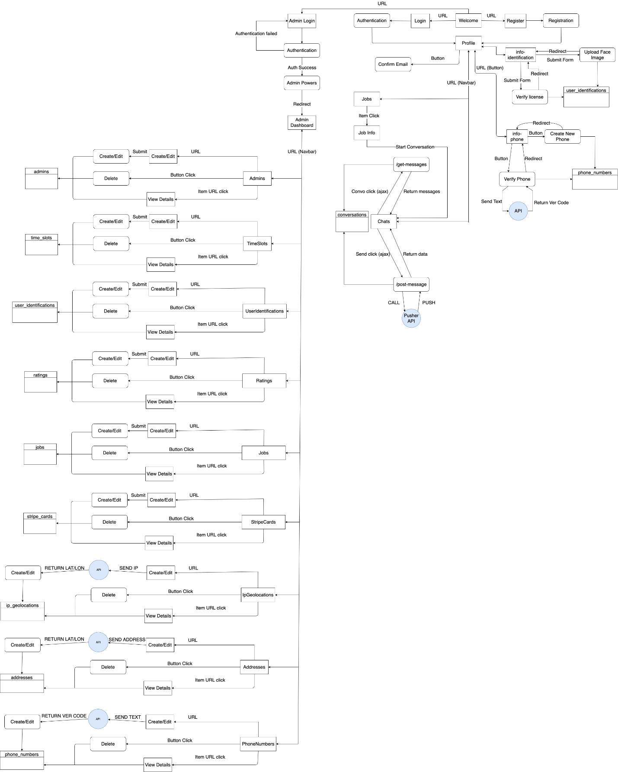
Figure 6.3 State Transition Diagram
The controllers decide the pages that can be seen based on assigned rules. Below the code for the routes that define the controllers will be explained.

Routes
Only logged in Users can view these routes:
Route::get('/', function () {
$jobs = \App\Models\Job::get();
return view('welcome', ['jobs'=>$jobs]);
});
The route shows a home page: By default, it describes the list of jobs and details about the responsibilities and expectations for the job.
Route::get('/job/{url}', function ($url) {
$job = \App\Models\Job::where('unique_url', $url);
return view('job', ['job'=>$job, 'user'=>\Auth::user()]);
})->name('job');
The route shows a job and the information from the job.
Auth::routes();
The helper class that helps you generate all the routes required for user authentication.

User Routes
Routes that might be get only from user’s authentication:
Route::get('/home', 'UserController@index')->name('home');
name('home') is defined by Route::get('/home', 'UserController@index'), which shows home page and executes index function with ('/home') parameter from UserController class extending Controller Class. In the home page, there are a list of jobs, the price, and details about the job.
Route::get('/profile', 'UserController@profile')->name('profile');
name('profile') is defined by Route::get('/profile', 'UserController@index'), which shows user profile page and executes index function with ('/profile') parameter from UserController class extending Controller Class. In the profile page, it is possible to verify the phone number, the e-mail address, the home address, and the important documents.
Route::get('/professionals', 'UserController@professionals')->name('professionals');
name('professionals') is defined by Route::get('/users', 'UserController@professionals'), which shows the page containing the list of job offering professionals and executes professionals function with ('/professionals') parameter from UserController class extending Controller Class. In the page, the full list of professionals are available, with the distance, price and job search.
Route::get('/info-address', 'UserInfoController@address')->name('info-address');
name('info-address') is defined by Route::get('/info-address', 'UserInfoController@address'), which describes an address of either the job professional or customer and executes address function with ('/info-address') parameter from UserInfoController class extending Controller Class.
Route::get('/info-phone', 'UserInfoController@phone')->name('info-phone');
name('info-phone') is defined by Route::get('/info-address', 'UserInfoController@phone'), which describes a phone of either the job professional or customer and executes phone function with ('/info-phone') parameter from UserInfoController class extending Controller Class.
Route::post('/info-phone', 'UserInfoController@newPhonePost');
Posts new phone of the user executing newPhonePost function of UserInfoController class extending Controller Class and writing to /info-phone directory.
Route::post('/info-phone-verify', 'UserInfoController@verifyPhonePost')->name('verify-info-phone');
name('verify-info-phone') is defined by Route::post('/info-phone-verify', 'UserInfoController@verifyPhonePost'), which posts the user's phone number verification and executes verifyPhonePost function with ('/info-phone-verify') parameter from UserInfoController class extending Controller Class.
Route::get('/chats', 'ChatsController@index')->name('chats');
name('chats') is defined by Route::get('/chats', 'ChatsController@index'), which describes the page with the chats of user and executes index function with ('/chats') parameter from ChatsController class extending Controller Class. In the page all chats and the messages of chats might be seen.
Route::post('/load-latest-messages', 'ChatsController@getLoadLatestMessages')->name('chat-latest-messages');
name('chat-latest-messages') is defined by Route::post('/load-latest-messages', 'ChatsController@getLoadLatestMessages'), which posts the latest chats' messages of the user and executes getLoadLatestMessages function with ('/load-latest-messages') parameter from ChatsController class extending Controller Class.
Route::post('/chat-send-message', 'ChatsController@postSendMessage')->name('chat-send-message');
name('chat-send-message') is defined by Route::post('/chat-send-message', 'ChatsController@postSendMessage'), which posts the sent messages of the user and executes postSendMessage function with ('/chat-send-message') parameter from ChatsController class extending Controller Class.
Route::get('/stripe-payment', 'UserController@stripePayment')->name('stripe-payment');
name('stripe-payment') is defined by Route::get('/stripe-payment', 'UserController@stripePayment'), which describes the stripe payment by a user and executes stripePayment function with ('stripe-payment') parameter from UserController class extending Controller Class.
Route::post('/stripe-payment-charge', 'UserController@stripePaymentCharge')->name('stripe-payment-charge');
name('stripe-payment-charge') is defined by Route::post('/stripe-payment-charge', 'UserController@stripePaymentCharge'), which charges the stripe payment from a user by executing stripePaymentCharge function with ('stripe-payment-charge') parameter from UserController class extending Controller Class.
Route::get('messages', 'MessageController@fetchMessages');
Gets the messages from messages table executing fetchMessages function of MessageController class extending Controller Class.
Route::post('messages', 'MessageController@sendMessage');
Posts the messages executing sendMessage function of MessageController class extending Controller Class and writing to messages table.
Route::get('/private-messages/{user}', 'MessageController@privateMessages')->name('privateMessages');
name('privateMessages') is defined by Route::get('/private-messages/{user}', 'MessageController@privateMessages'), which describes the private messages of the user and executes privateMessages function with ('/private-messages/{user}') parameter from MessageController class extending Controller Class.
Route::post('/private-messages/{user}', 'MessageController@sendPrivateMessage')->name('privateMessages.store');
name('privateMessages.store') is defined by Route::post('/private-messages/{user}', 'MessageController@sendPrivateMessage')->name('privateMessages.store'), which posts the private messages to selected user by executing sendPrivateMessage function with ('/private-messages/{user}') parameter from MessageController class extending Controller Class.

Admin Routes
Routes that might be get only from admin user’s authentication:
Route::get('/users', 'UserController@users')->name('users');
name('users') is defined by Route::get('/users', 'UserController@index'), which shows the list of users and executes index function with ('/users') parameter from UserController class extending Controller Class. In the users page, admins might see the users details: id, name, email, date_of_birth, email_verified_at, rating, jobs_finished, profile_picture_url, stripe_customer_id, created_at, updated_at.

